Cat Coding Project Design
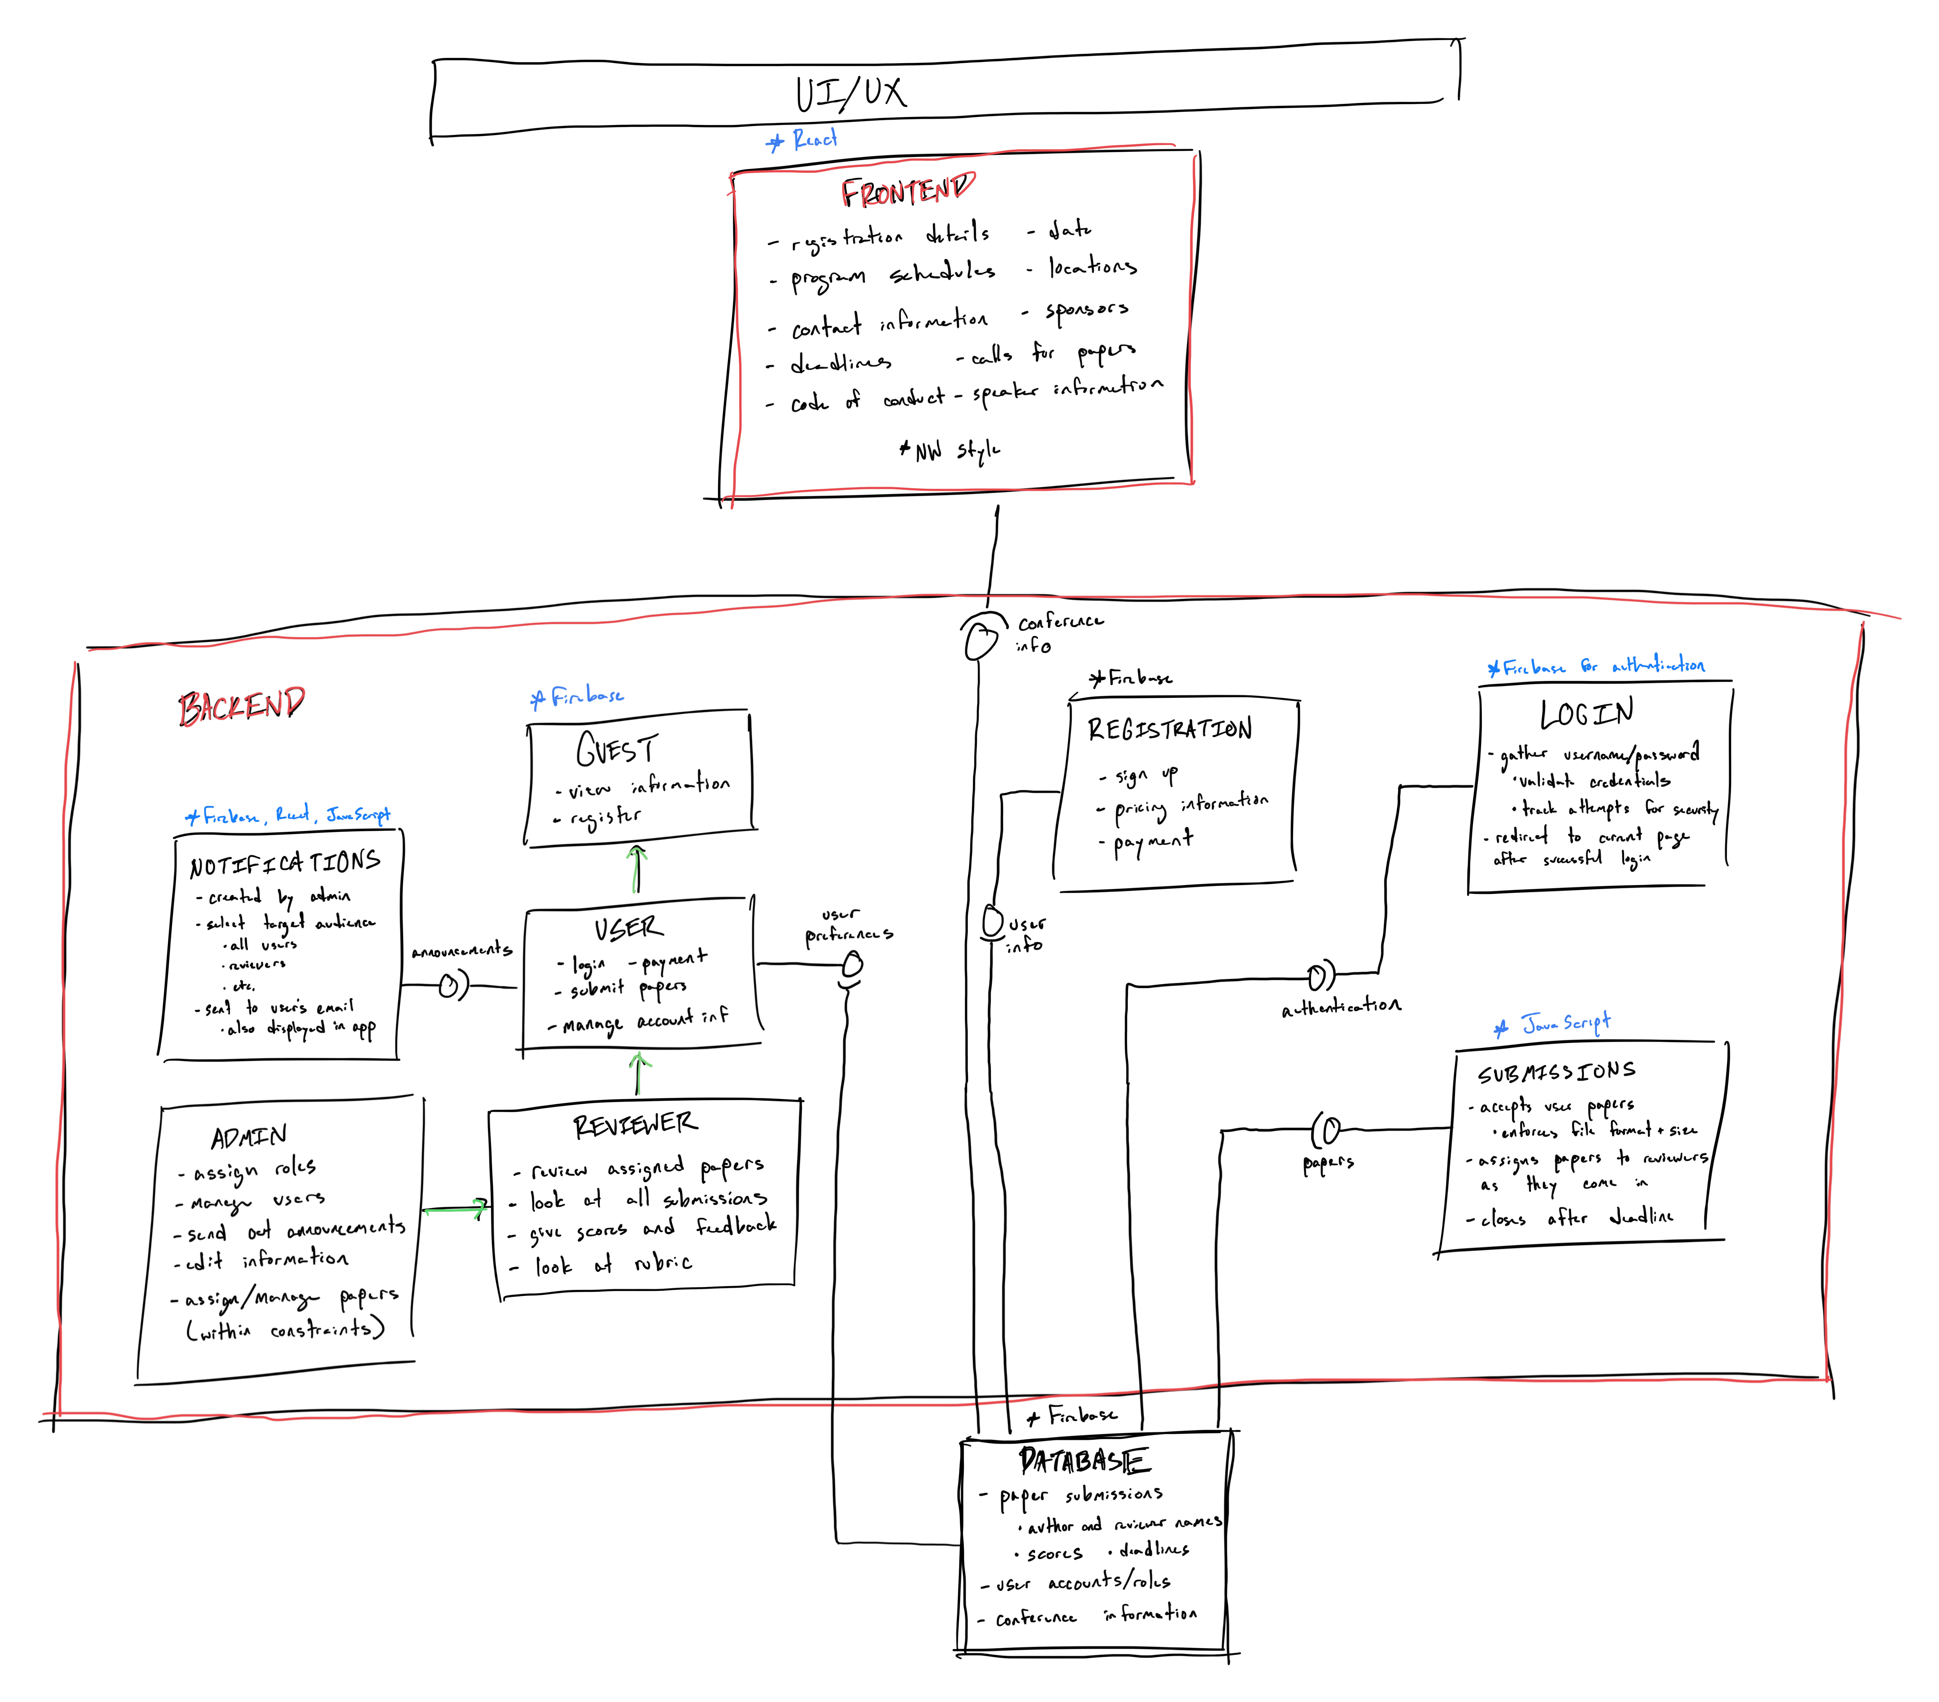
TASK NAME | 1 | 2 | 3 | 4 | 5
CONTRIBUTORS | All Team Members | All Team Members | All Team Members | All Team Members | All Team Members

